**ONLINE PIZZA DELIVERY APPLICATION**

**SOFTWARE REQUIREMENTS SPECIFICATIONS**

**U60902**

**ARSHAD AK**

Table of Contents

**1.Introduction3**

1.1Need and Purpose3

1.2Intended Audience3

1.3References3

1.4Overview of document3

**2.Description3**

2.1Features and Function3

2.2 Operating Environment 3

2.2.1 Hardware4

2.2.2 Software4

**3.Specification Requirement4**

3.1Performance Requirement4

3.2Design constraints 5

3.3Overview of Data Requirements5

**4.Input And Output…………………………………………………………………………………………………………………………….5**

**5.Design ……………………………………………………………………………………………………………………………………………11**

5.1 ER Diagram……………………………………………………………………………………………………………………………………11

5.2 Class Diagram……………………………………………………………………………………………………………………………….12

**6.Test Cases………………………………………………………………………………………………………………………………………13**

**7.Conclusion……………………………………………………………………………………………………………………………………..13**

1.Introduction

1.1 Need and Purpose

Online Pizza Ordering Website is web application for a restaurant. The user can register, login, order pizza and reserve seats and delete and update options for pizza and reservation.

It helps the client to reduce the time by spending less time on receiving calls for booking seats and order. Thus increasing the clients efficiency and cost of running and less human effort .

1.2 Intended Audience

This SRS is intended to be used by the UST Global .

1.3 References

1. [www.stackoverflow.com](http://www.stackoverflow.com)

2.Google Search results

3.www.w3schools.com

1.4 Overview of Document

The first section of SRS gives a brief introduction on Online Pizza Management System. This section also provides the reference information for intended audience and scope & purpose of the product. The second section provides an overall description of the application, functional & non-functional details. The third section is about the hardware and software requirements and technologies used.

2. Description

2.1 Features and Functions Features

It is an application used to

1)register new users

The new user can register in and invalidated inputs are checked and the error messages are shown

2) login users

The existing user can login and order pizza and reserve table the system checks whether the login user is valid and returns to welcome.

3) place orders

The valid user can login and place order for any number of pizza

4) show orders

Show all ordered items of the user

5) delete orders

The user can delete order

6) place reservation

Place the reservation for a particular date.

7) show reservation

Show reservations made by the user for all dates

2.2Operating Environment

2.2.1 Hardware

The application requires an

1) Entry-level PC for smaller number of user accounts (like, when data is being stored locally).

2) For larger no. of restaurant account , a server class machine is recommended.

2.2.2 Software

The application requires an

1)Microsoft Windows OS or Dos

2)Apache TomCat server

3)Eclipse IDE

4)Java Development Package

5)Spring plugin and Hibernate plugin must be installed in the IDEs

3. Specific Requirements

3.1 Performance Requirements

1)Number of Accounts:

* Maximum number of accounts Limited by size of server storage capacity.

2)The response time:

* Size of database due to searching process
* Time taken by the hibernate ORM to convert queries into My SQL dialects.
* Time taken by the My SQL to execute the queries.

3.2 Design Constraints

* Central Server should be on-line round the clock.
* The application uses hibernate which may result in a certain lag for the user.

3.3 Overview of Data Requirements

The product is completely data oriented. In the pizza application, the users themselves would input the various details of Customer for updating, processing or retrieval of data and for new customers, required fields for registration will be filled. In a normal restaurant, the user would input less amount of data thereby keeping the more privacy for themselves.

4. Input And Output

**Input**

* Username and password for login to the application.
* User details for registration.
* Number of seats and date for reservation.
* The required pizza, size of pizza, toppings required and quantity.
* Delete the order.

**Output**

* The status after login, registration, reservation and order.
* The bill after confirming the order.

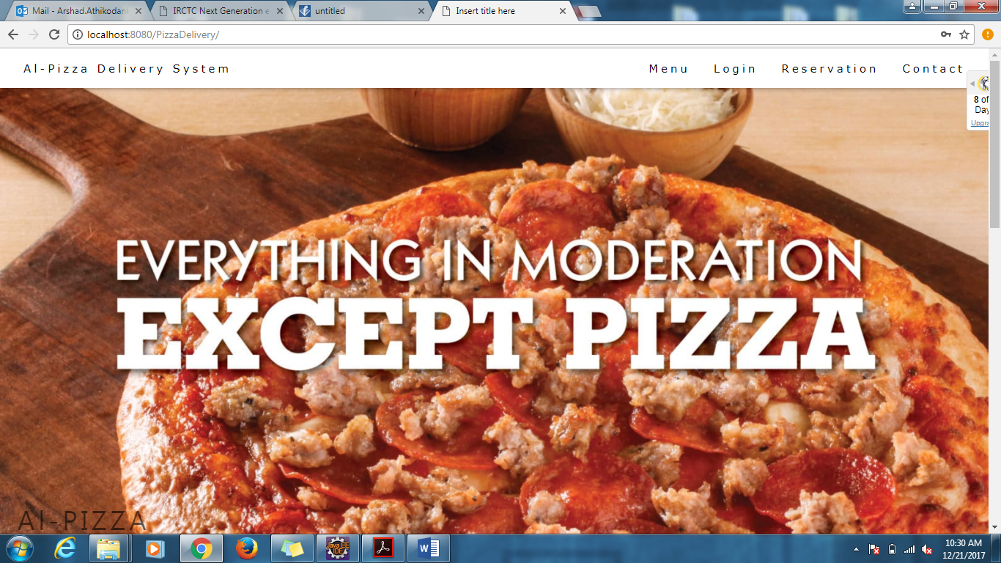

MAIN PAGE

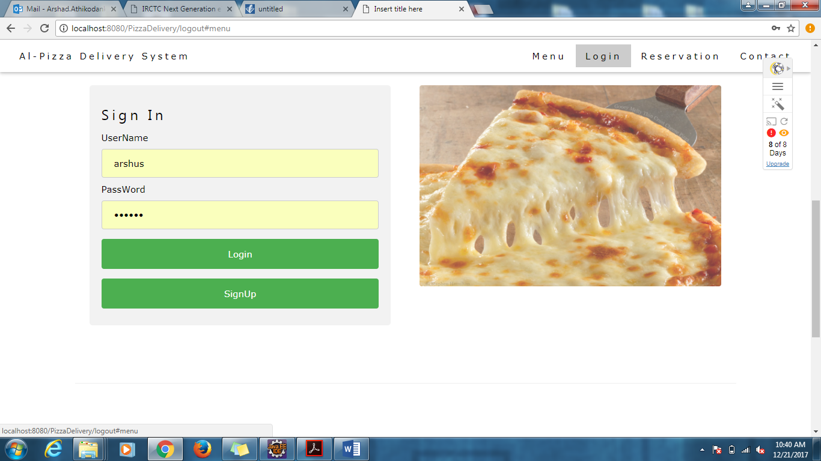

LOGIN

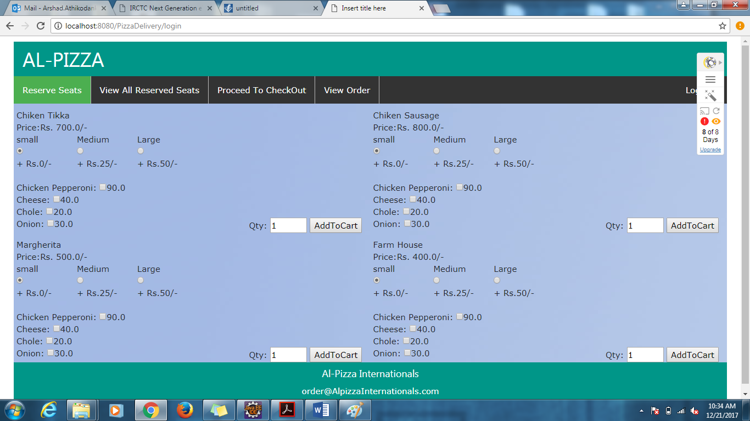

ORDER PAGE

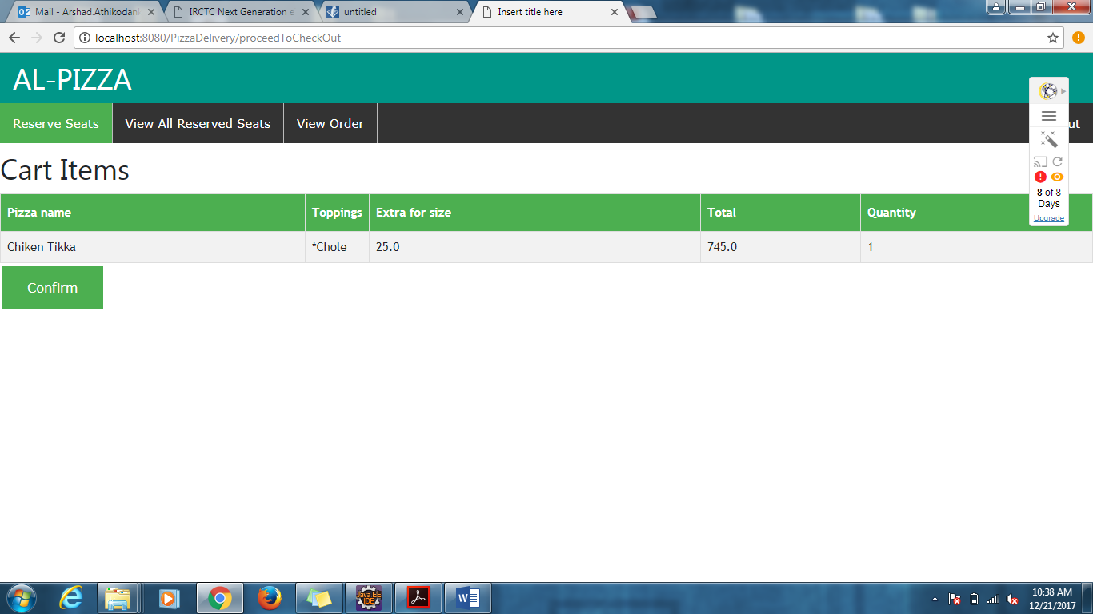

CHECK OUT

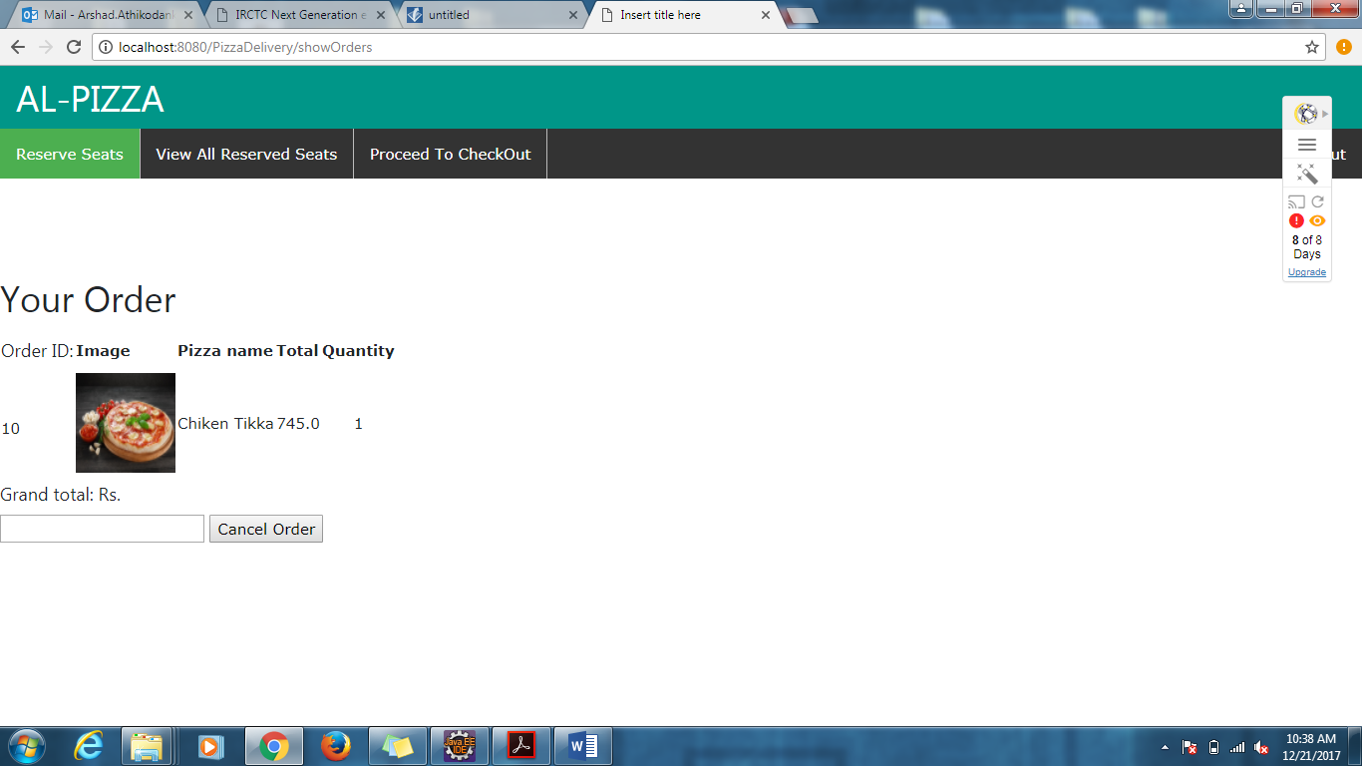

VIEW ORDER AND DELETE

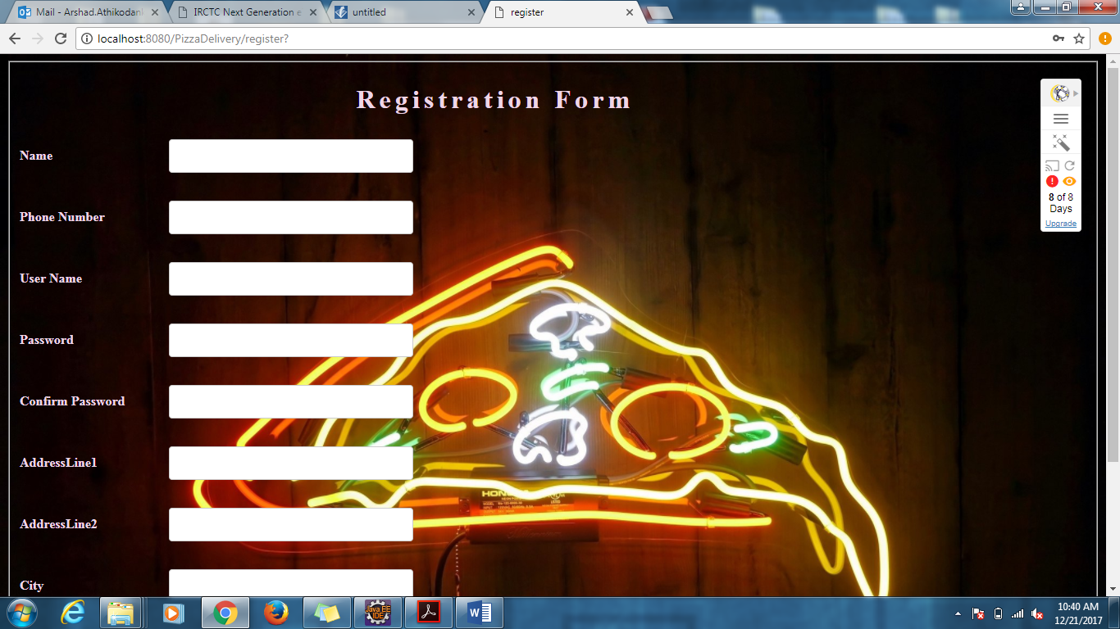

REGISTRATION

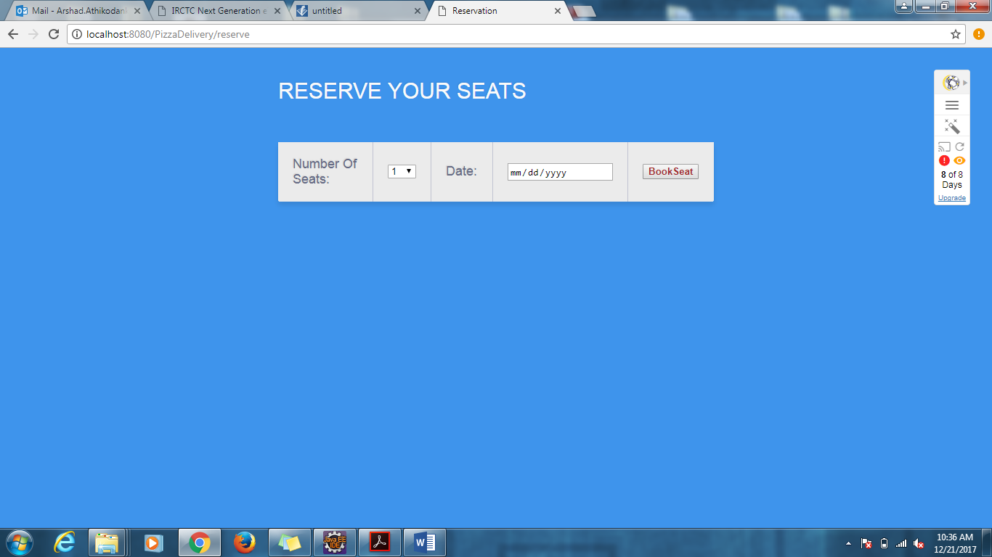

SEAT RESERVATION

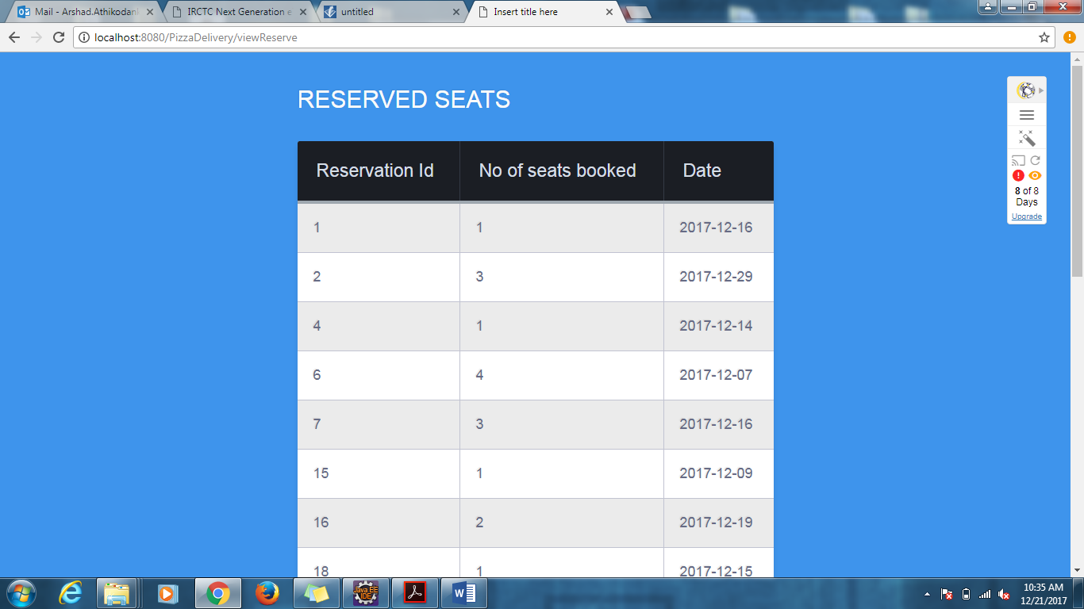

RESERVED SEATS

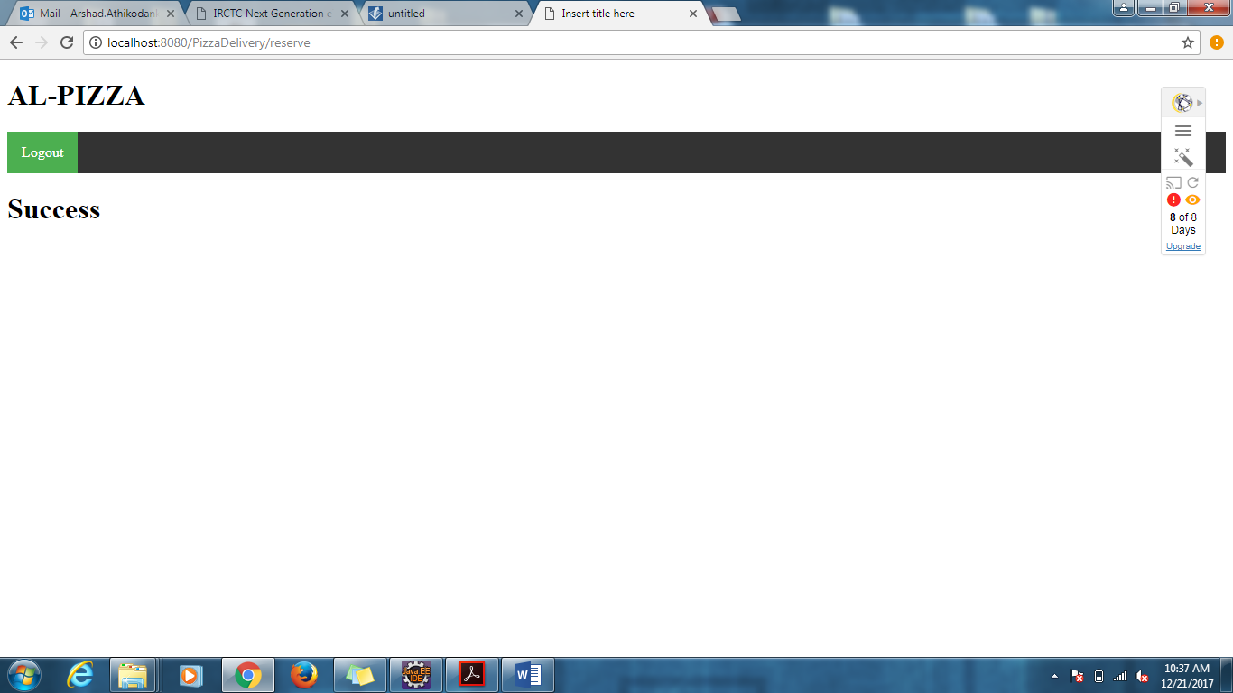

SUCCESS RESERVATION

5. Design

5.1 ER diagram

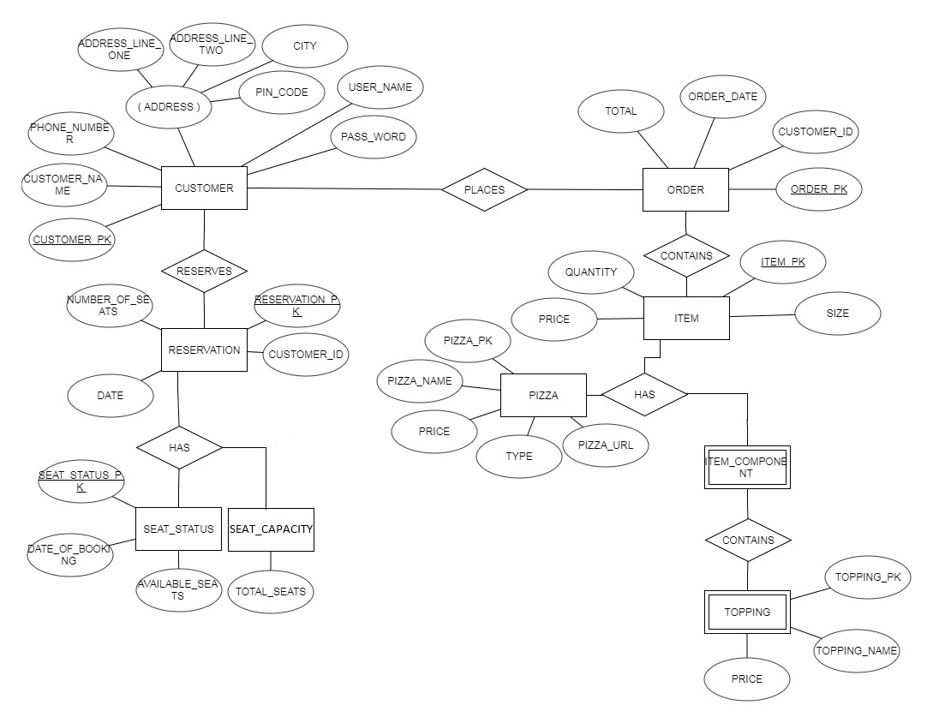

5.2 Class Diagram

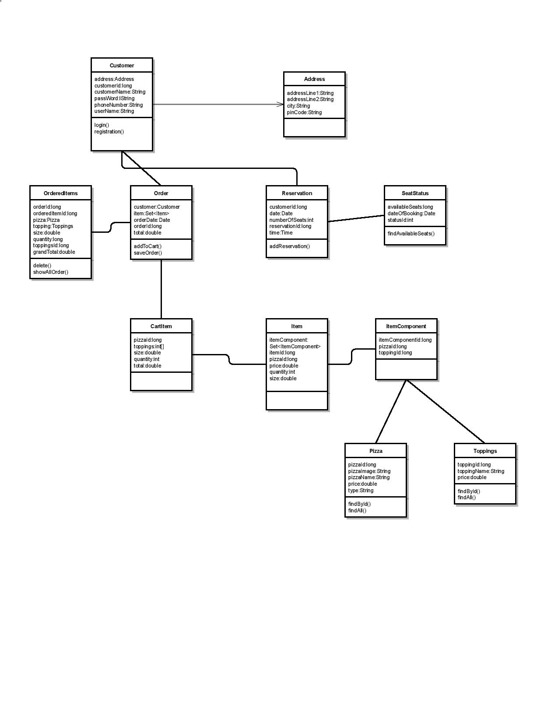

6.Test Cases

The test plan is attached along.

7.Conclusion

This project is developed to satisfies the needs of pizza customers in a simple way. In this pizza delivery system, registered users can perform customized pizza ordering, view menu card and seat reservation at any time through a single button click. Thus, standardize the system with database features which allows customers to review the details. Moreover, this application provides simple user interface.